## Lab 5 – Theory questions

Please submit your answers to the following questions on paper.

1. Describe what a ‘process’ is.

**A "process" is an independent program or task in a computer's memory that is managed and executed by the operating system. It has its own resources, execution environment, and runs as a separate entity, capable of performing specific functions.**

2. What impact does a process have on the systems hardware?

**A process consumes system resources, including CPU, memory, and I/O, affecting hardware performance and resource allocation. Multiple processes can compete for these resources, leading to system responsiveness and efficiency variations.**

3. Explain the following from the screen shot below.

1. PID :

**PID is a unique numeric identifier for a running process in a computer's operating system, used for process management**.

1. %CPU :

**%CPU represents the percentage of the CPU's computational power that a process is currently using, indicating its impact on the system's CPU resources.**

1. %MEM :

**%MEM is the percentage of physical memory (RAM) consumed by a process, showing how much memory it utilizes.**

1. COMMAND :

**COMMAND refers to the name or description of the program or command associated with a specific process, providing information about what the process is doing.**

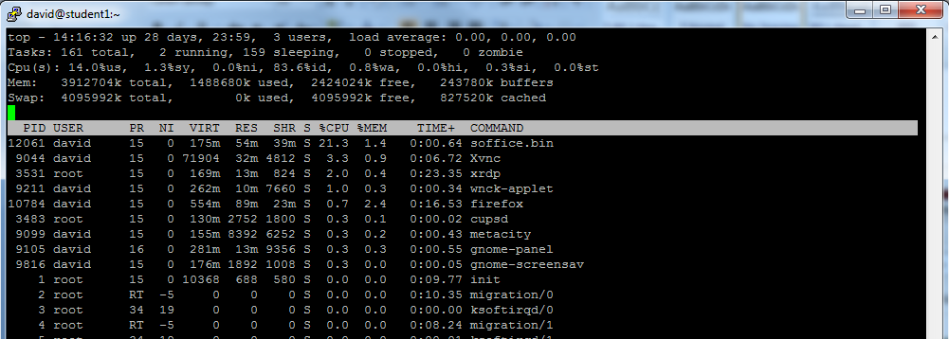

4. If a command was taking a large amount of system resources (memory and processing) and this was causing some system performance issues, what could a system administrator do to solve the problem?

**A system administrator can identify the resource-intensive command using tools like `top` or `ps`, then terminate the process using `kill <PID>` and optimize it. For background tasks like `sleep`, scheduling and setting resource limits can help alleviate system performance issues.**